BSLBATT ESS-GRID HV Pack Battery Awarded IEC 62619 Certification
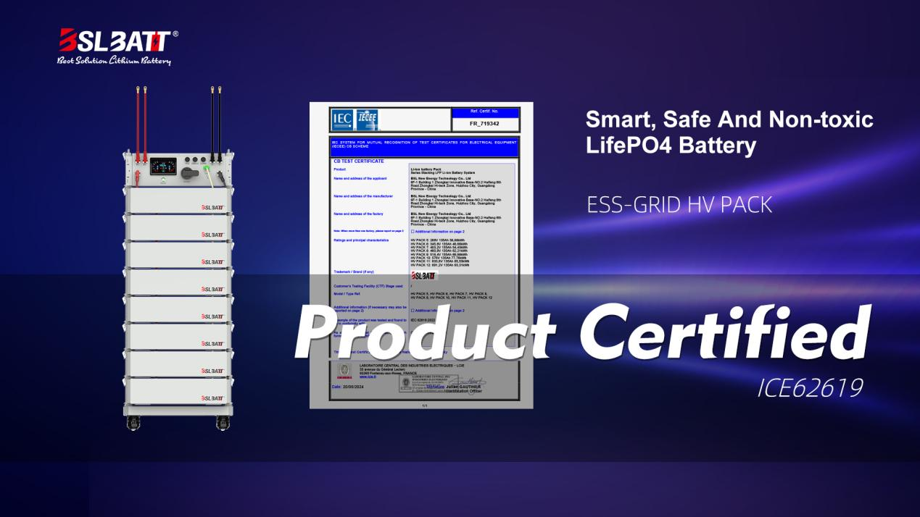

A Game-changer in Small-scale Industrial and Commercial Energy Storage

Huizhou, China - Leading energy storage manufacturer BSLBATT announces that its ESS-GRID HV PACK series, designed for small-scale industrial and commercial energy storage, has secured the IEC 62619 certification. This milestone not only demonstrates that BSLBATT-manufactured batteries meet international certification standards but also attests to BSLBATT's enduring commitment to providing high-performance, reliable, and safe energy storage solutions.

The IEC 62619 sets out the requirements and tests for the safe operation of rechargeable batteries and battery groups used in industrial applications, representing a hallmark of quality and safety. It rewards products that comply with the stringent technical safety requirements for secondary lithium cells and batteries for stationary applications. The ESS-GRID HV PACK is BSLBATT's third product to obtain the IEC 62619, reinforcing BSLBATT's pioneering status in the energy storage sector and emphasizing the robustness and reliability of BSLBATT's storage products.

Designed to address the energy storage needs of small-scale industrial and commercial sectors, BSLBATT's ESS-GRID HV PACK energy storage battery focuses on enhancing conversion efficiency, bolstering energy resilience, and prolonging battery longevity. By meeting the rigorous criteria of IEC 62619, the ESS-GRID HV Pack sets new standards in terms of reliability and safety, mainly targeting manufacturers, solar farms, schools, hotels, hospitals, communities, charging stations, villages, and other key sectors to provide energy backup and enhance utility and cost-effectiveness.

"Before product design, safety is always a primary consideration for the BSLBATT R&D team. The ESS-GRID HV Pack uses the top three global cell brands — EVE — and has an aerosol fire extinguishing system built into each battery pack to effectively ensure product safety," said Product Director Lin Peng. "We fully recognize the importance of IEC 62619 for energy storage products. Successfully obtaining this certification validates BSLBATT team's commitment to product safety and reliability."

With a modular design and secondary BMS control logic, the ESS-GRID HV PACK boasts exceptional expansion capabilities, extending from 38kWh to 466kWh, providing a range of capacity options to meet diverse market and end-user energy demands. The smart buckle bracket design allows for quick assembly, saving time and installation costs.

About BSLBATT Battery — SOLAR

Founded in 2012 and headquartered in Huizhou City, Guangdong Province, BSLBATT specializes in the research and development, design, production and manufacturing of lithium battery products in different fields. Over the years, it has been committed to providing customers with the best lithium battery solutions and taking the lead in launching innovative, reliable and safe energy storage solutions to meet the evolving market needs. BSLBATT energy storage batteries are currently sold and installed in more than 50 countries worldwide, providing power backup and reliable power supply for more than 90,000 homes.

For more information, visit our website: https://www.bsl-battery.com/

Contact:

Media/Marketing

Aydan L.
aydan@bsl-battery.com

Sales/Partnerships

Haley N.
inquiry@bsl-battery.com

